Experiment 2: Water Jug Problem

Aim
To solve the Water Jug Problem using Artificial Intelligence techniques and obtain exactly 2 litres of water using a 4-litre and a 3-litre jug.

Objective
To find a sequence of operations (fill, empty, and pour) that results in exactly 2 litres of water in one of the jugs.

Algorithm
Start the program.
- Initialize the 4-litre and 3-litre jugs as empty.
- Check whether the goal state (2 litres) is reached.
- If the 4-litre jug is empty, fill it completely.
- If the 3-litre jug is full, empty it.
- Otherwise, pour water from the 4-litre jug into the 3-litre jug.
- Display the current state of both jugs.
- Repeat Steps 3–7 until one jug contains exactly 2 litres.
- Display Goal Reached and stop.

Python code
jug4 = 0
jug3 = 0
while jug4 != 2 and jug3 != 2:
if jug4 == 0:
jug4 = 4
elif jug3 == 3:
jug3 = 0

else:
transfer = min(jug4, 3 - jug3)
jug4 -= transfer
jug3 += transfer
print("4L =", jug4, "3L =", jug3)
print("Goal Reached")

Input
Jug Capacity = 4 Litres and 3 Litres
Goal = 2 Litres

Flowchart

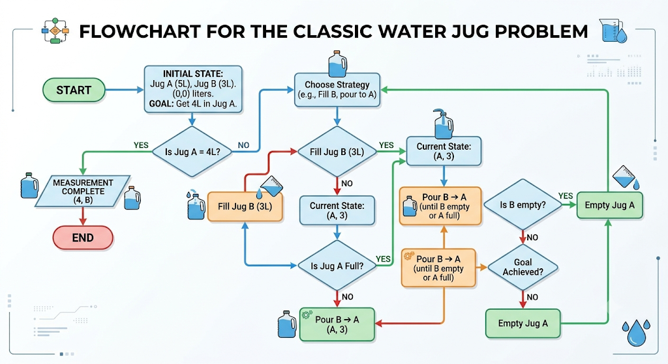

Output

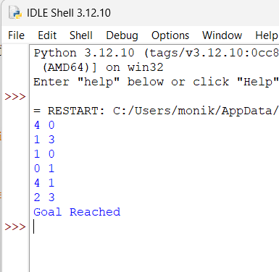

Result
The Water Jug Problem is solved successfully, and exactly 2 litres of water is obtained in one of the jugs.

